Keyestudio UNO PLUS Development Board

You need to know that keyestudio UNO PLUS development board is the core of this 4WD Mecanum Robot Car.

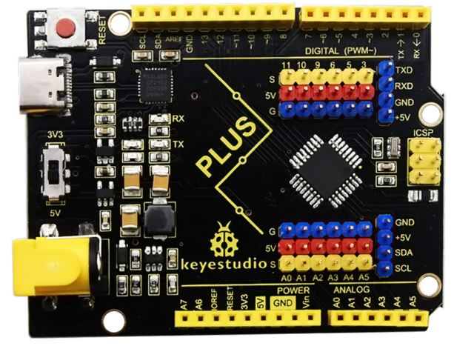
The core processor of the board is ATMEGA328P-AU, using a CP2102 chip as UART-to-USB converter. It has 14 digital input/output pins (of which 6 can be used as PWM outputs), 8 analog inputs, a serial port for communication, a 16 MHz crystal oscillator, a USB connection, a power jack, a ICSP plug as well as a reset button.

It supports everything you need for a microcontroller. You can connect it to your computer with a USB cable and power it through an external power connector (DC 7-12V) to start using it.
Microcontroller | ATMEGA328P-AU
Operating Voltage | 5V
Input Voltage | DC7-12V
Digital IO Pins | 14 (D0-D13)
PWM IO Pins | 6 (D3，D5，D6，D9，D10，D11)
Analog Input Pins | 8(A0-A7)
Flash Memory | 32 KB (ATMEGA328P-PU) of which 0.5 KB used by bootloader
SRAM | 2 KB (ATMEGA328P-PU)
EEPROM | 1 KB (ATMEGA328P-PU)
Clock Speed | 16 MHz

Element and Interfaces:
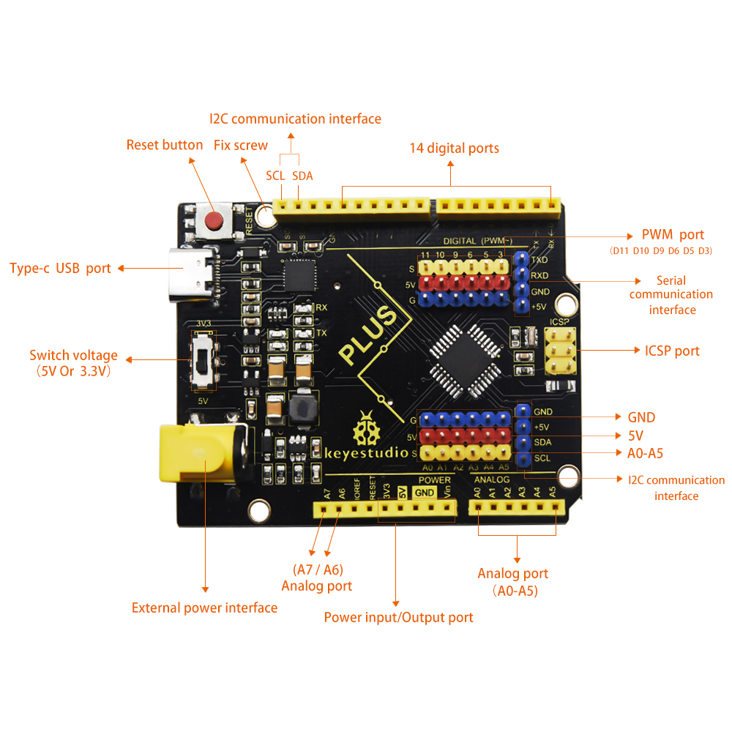

UNO PLUS Board and UNO Board
